St Francis Xavier School
Session -2020-21
Subject- Hindi
worksheet
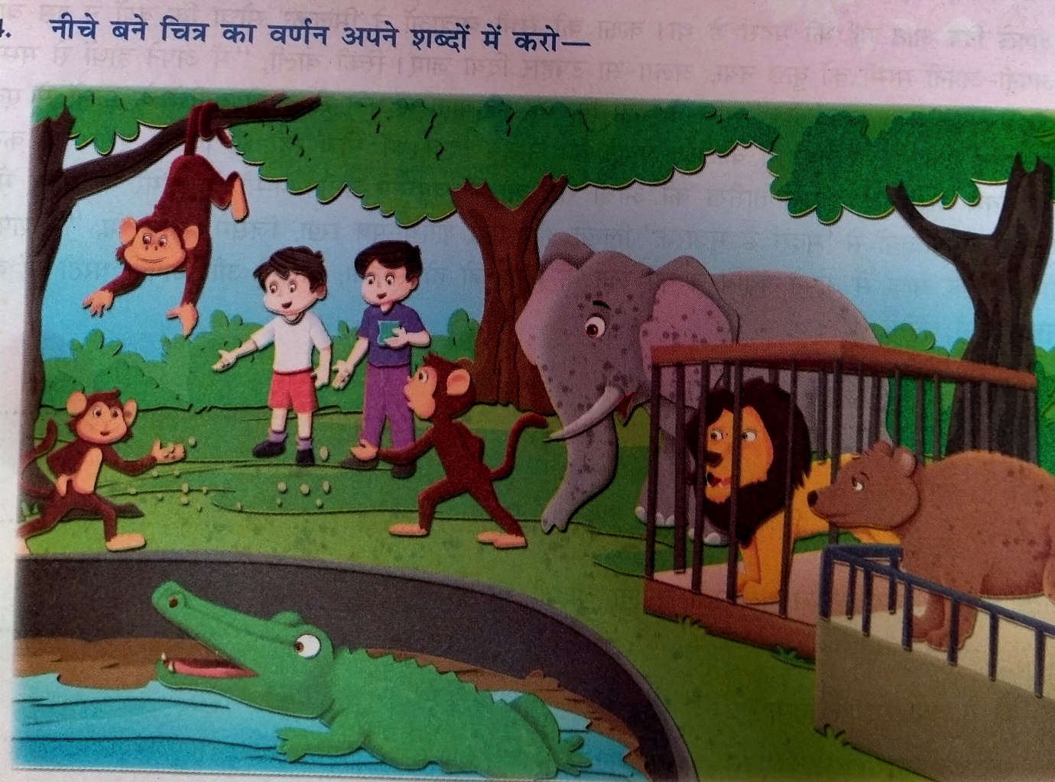
Class V

Word limit 100: -

